**Assignment 2**

1. Introduction
2. **Project Overview**

* **Purpose**

1. **Project Scope**

1. **Business Opportunity**

1. System overview
2. **Functional and Non-functional Requirement**

1. **Actor**
   1. Customer

* Access to the website and browse , choose what they want to buy
* Add to cart
* Checkout

1. Administrator

* Manage website
* Manage employee
* Resolve customer report and customer’s questions

1. Inventory staff

* Manage product in the inventory
* Add/Update/Delete product in the inventory
* Update quantity – status of the product (sold out or not).

1. SRS
2. List use case diagram

* Sign Up
* Log in
* Log out
* View a product
* View a product and buy right away
* View a product and add it to cart
* Update quantity in shopping cart
* Remove a product from shopping cart
* View order history
* Administrator add new employees
* Administrator delete employees
* Administrator update employees
* Administrator resolve user’s report
* Inventory staff add new product
* Inventory staff remove product
* Inventory staff update product

1. Use case diagram

* Customer Use case diagram

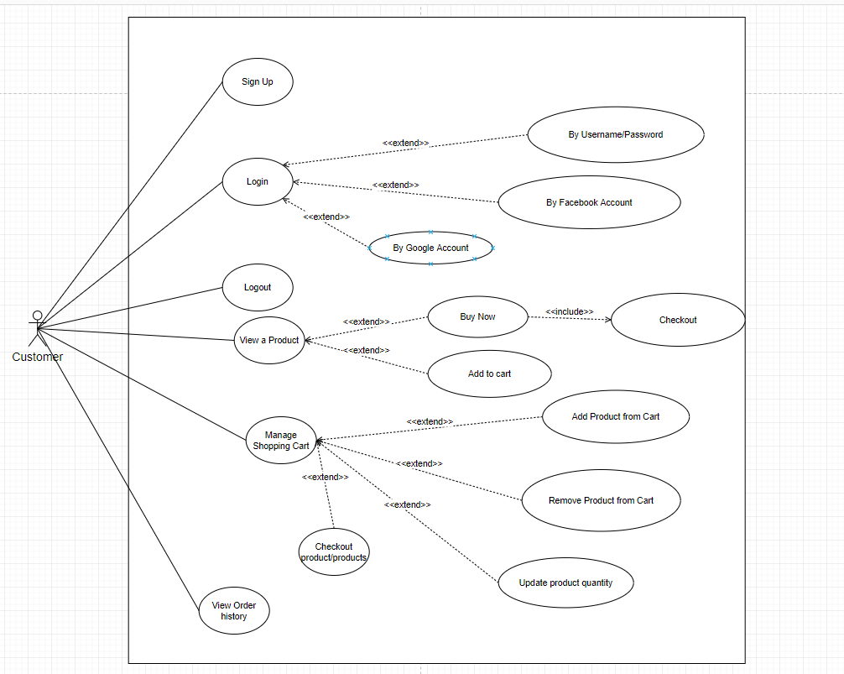

* Administrator use case diagram:

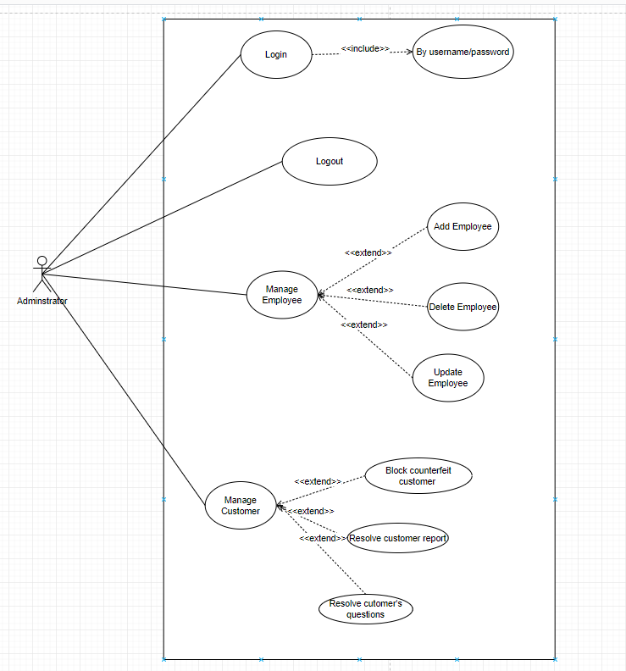

* Inventory Staff use case diagram:

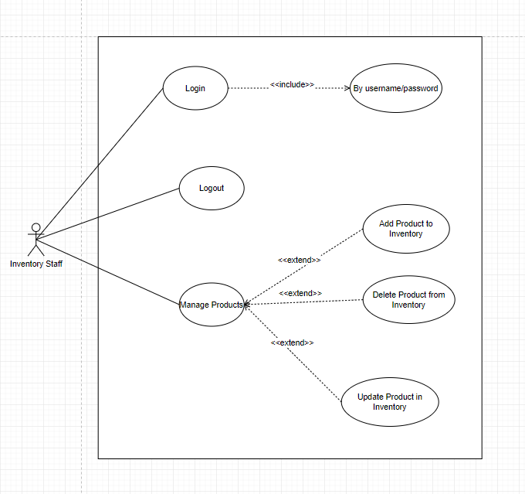

1. UC-11 Administrator manage employees (Delete employees)
   1. Description

Actor: Administrator

Detail description: Administrator want to remove employee that no longer working

* 1. Class diagram

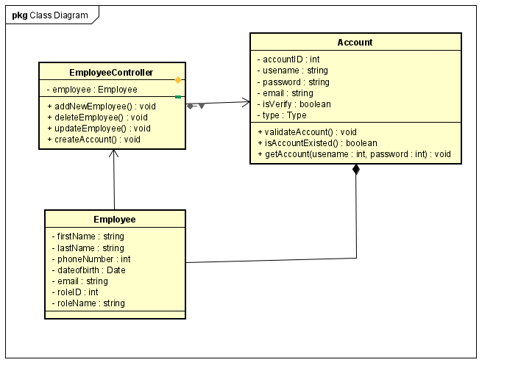

* 1. Sequence diagram

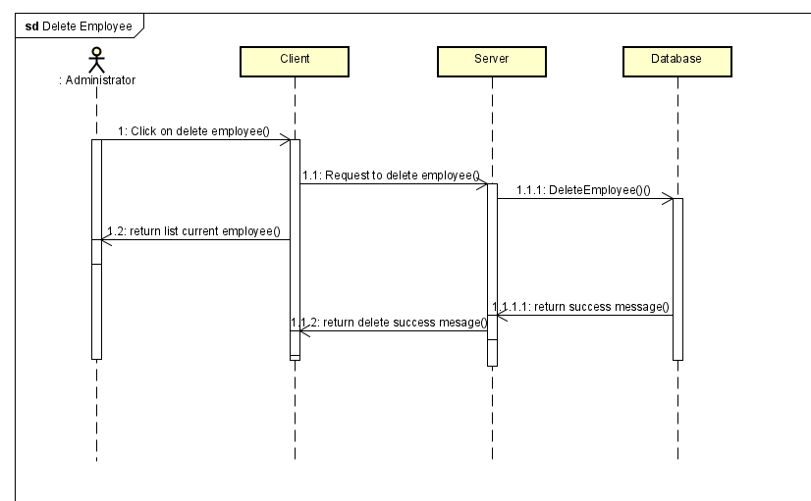

* 1. Screen design 1

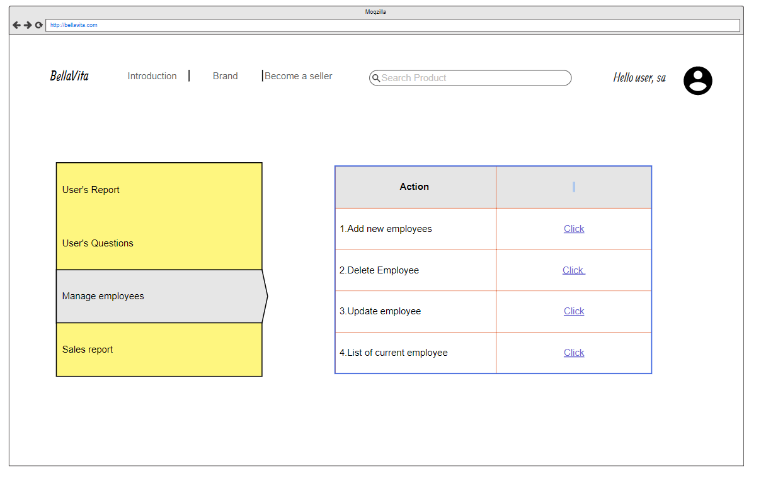

1. UC-12 Administrator manage employees (Update employees)

2.1 Description

* Actor: Administrator
* Detail description : Only administrator can update employees information in the system

2.2 Class diagram

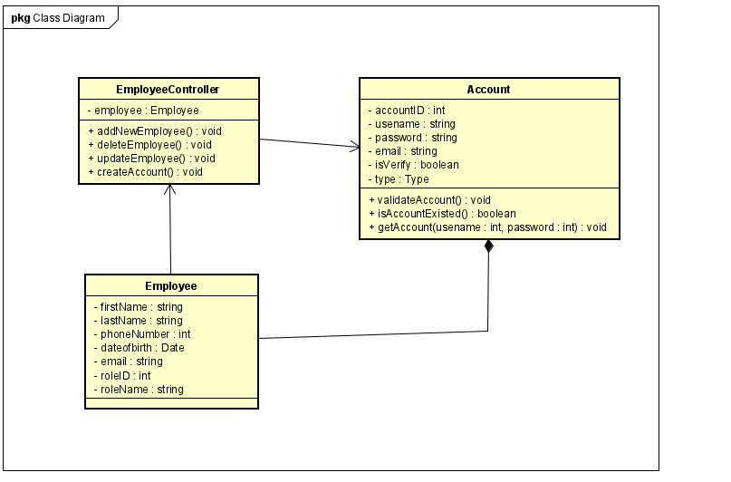

2.3 Sequence diagram

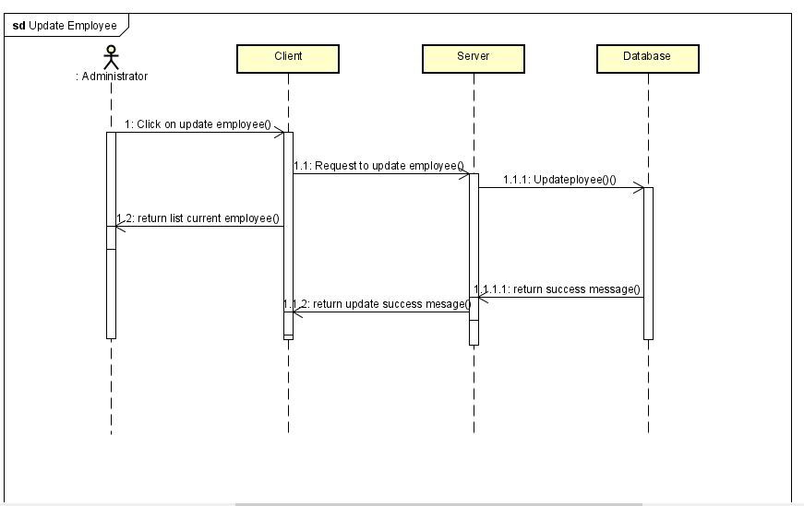

2.4  Screen design 2



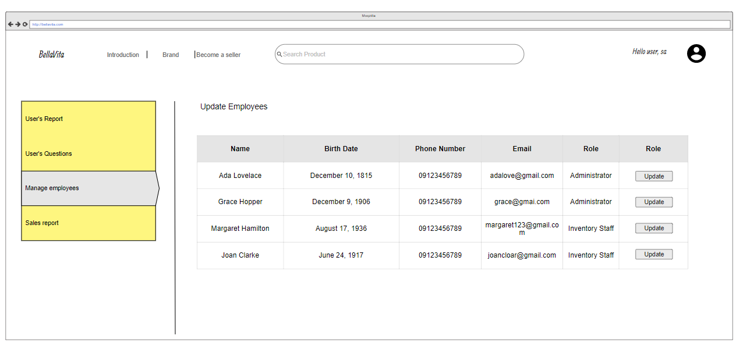

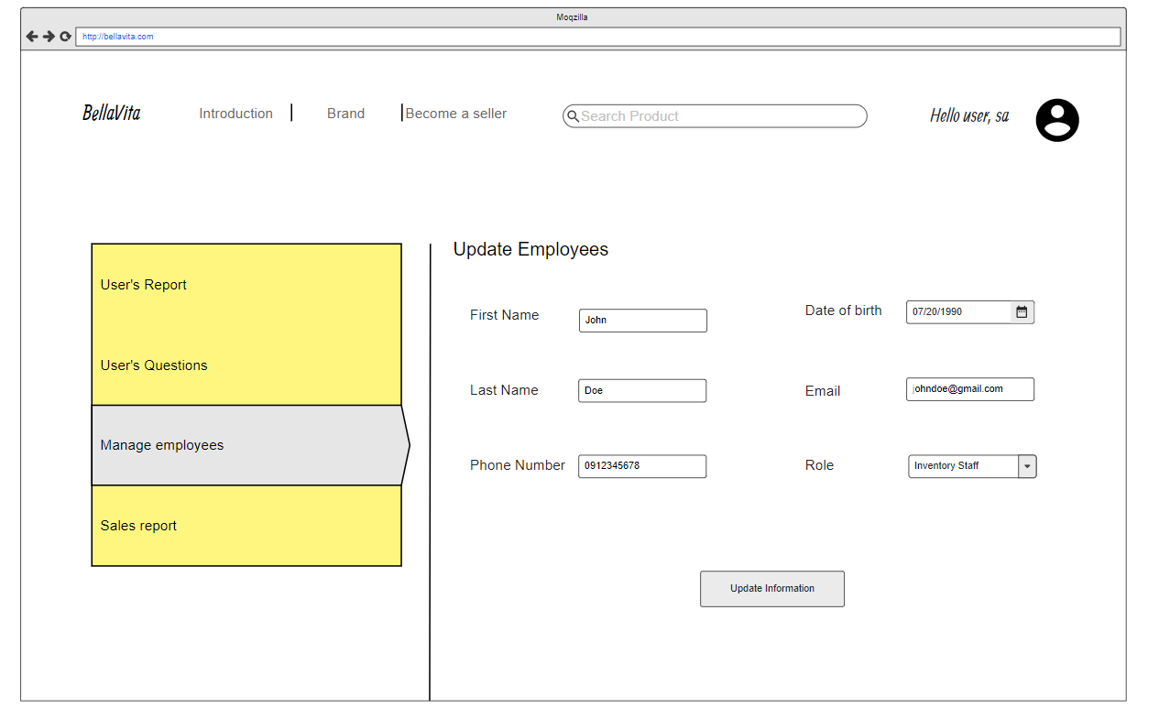

1. Administrator resolve customer report

3.1 Description

* Actor: Administrator
* Detail description : Administrator need to resolve user report about our products .Administrator consider what report are critical to user and the system and will have some action to the systems

3.2 Class digram

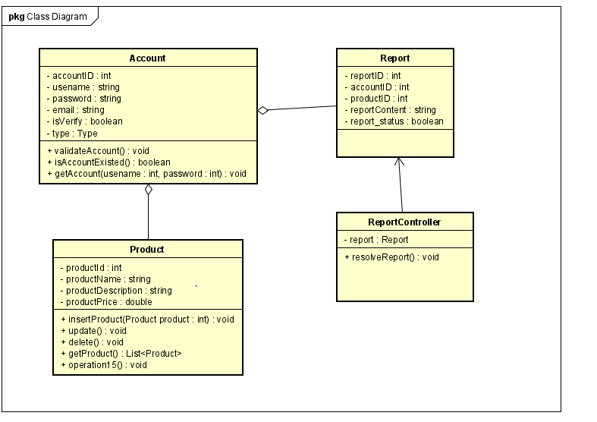

3.3 Sequence diagram

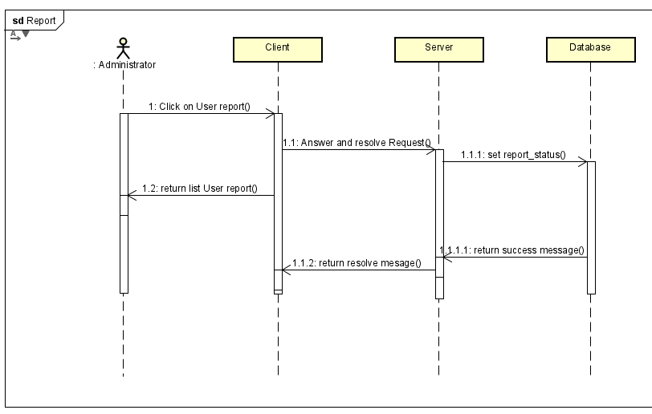

3.4 Screen design

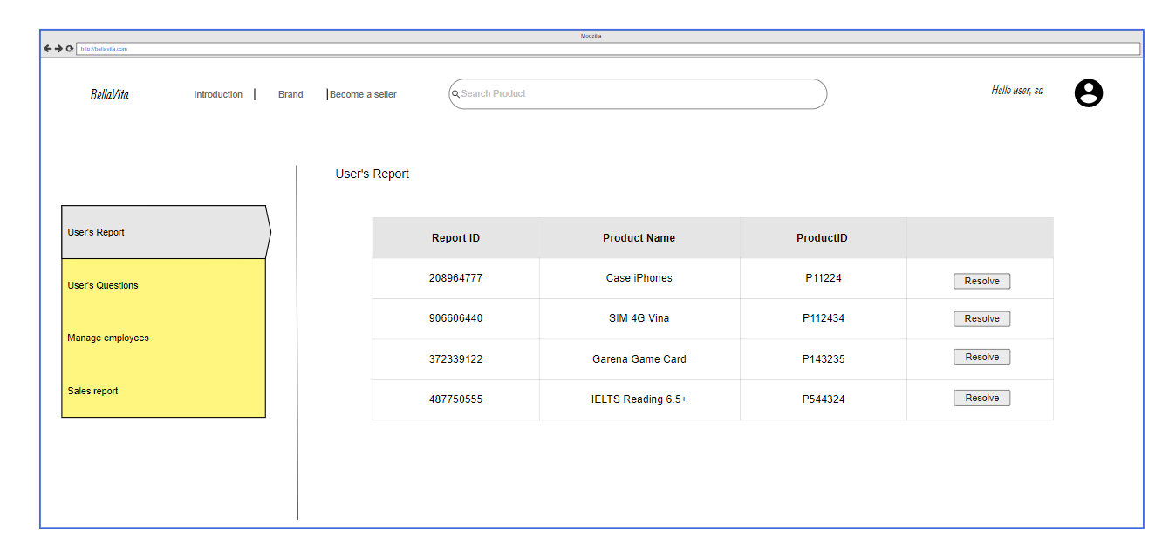

1. Inventory staff manage products (Add new products to inventory)

4.1 Description

* Actor: Inventory staff
* Detail description: To enrich the product, employees need to add new products to retain customers, this can only be done by the inventory staff.

4.2 Class diagram

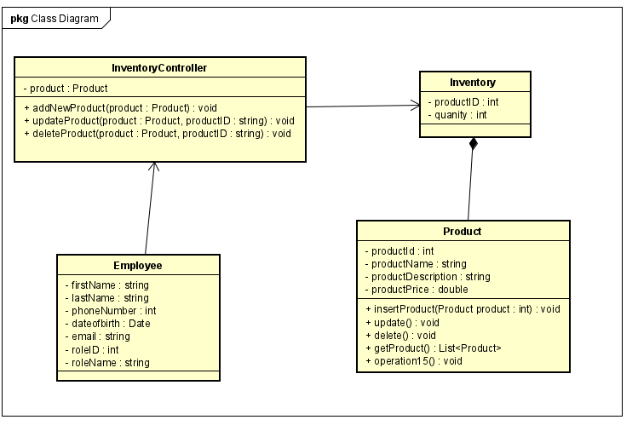

4.3 Sequence diagram

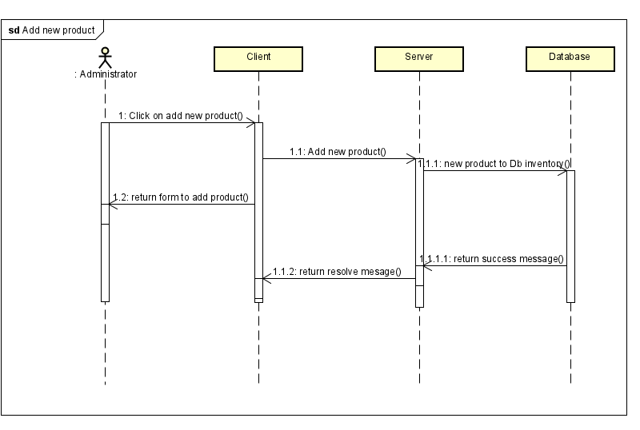

4.4 Screen design

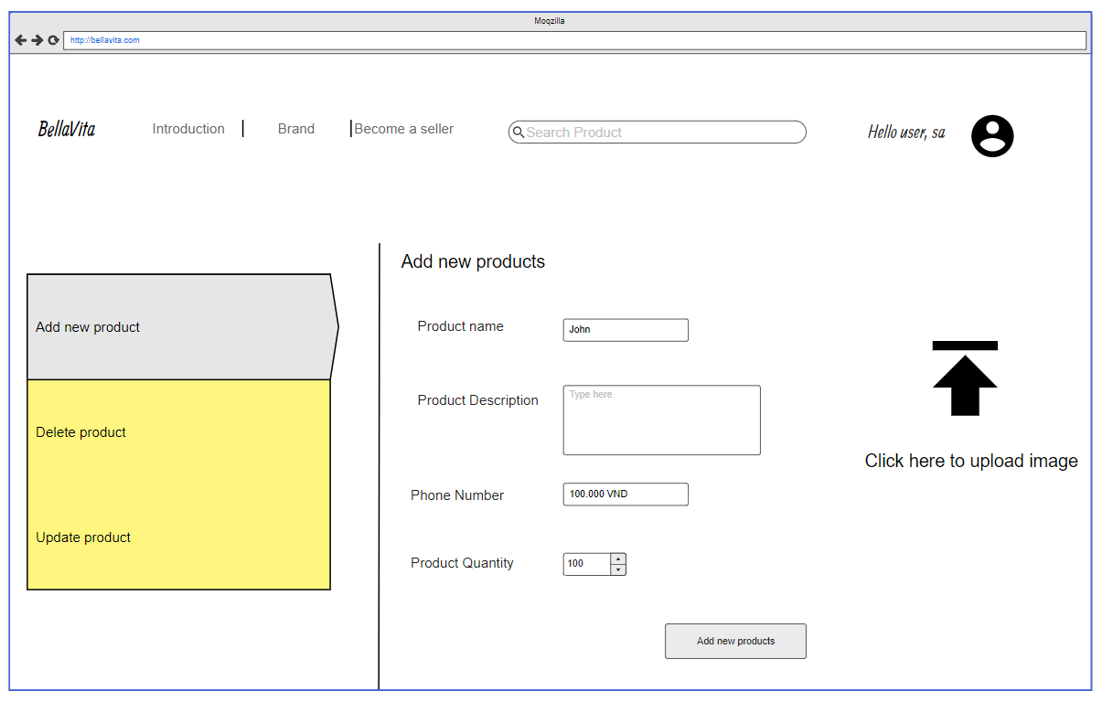

1. UC-15 Inventory staff manage products (Delete products from inventory)

5.1 Description

* Actor: Inventory staff
* Detail Description: Inventory staff need to remove product that profit is low or counterfeit or poor reviews from customers.

5.2 Class diagram

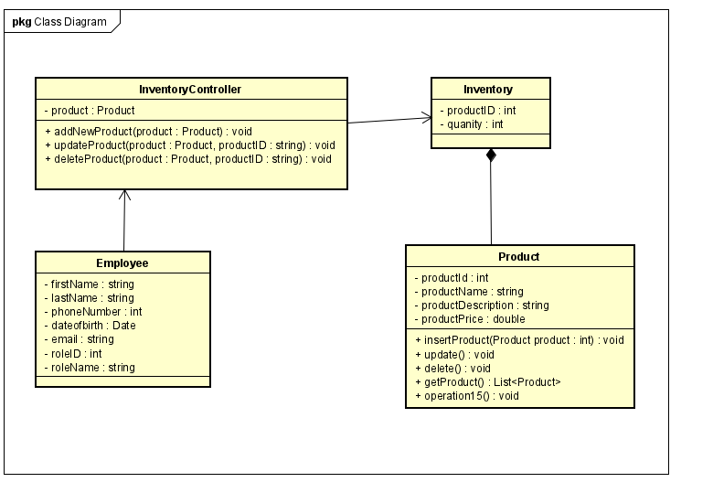

5.3 Sequence diagram

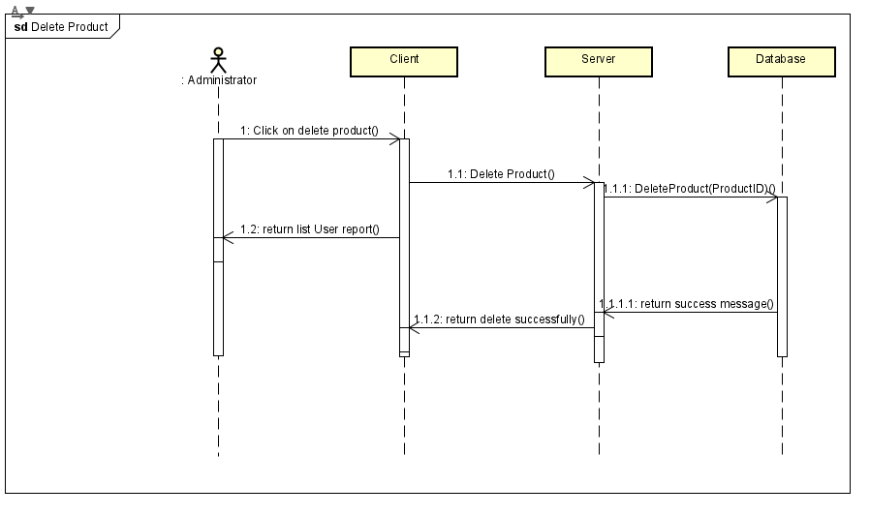

5.4 Screen design

